Za Alarm Center bih napravio zaseban enterprise modul, odvojen od Maintenance i Digital Twin.
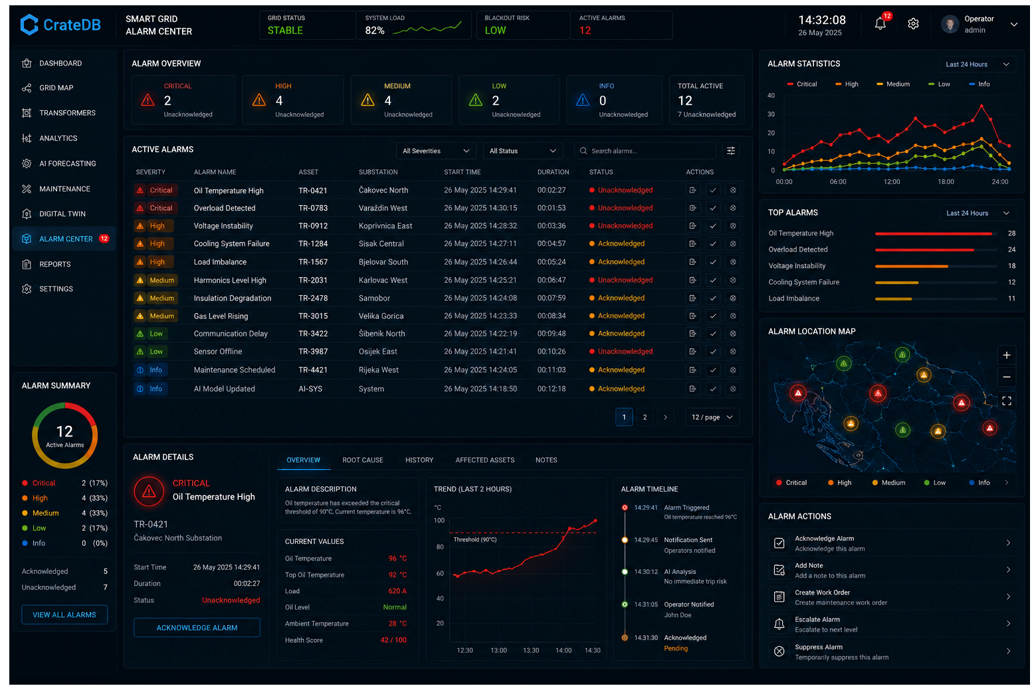
Cilj je da operator u jednom ekranu vidi:
- Active Alarms
- Critical Events
- Alarm Correlation
- Alarm Timeline
- Alarm Map
- Root Cause Analysis (AI)
- Acknowledgement Workflow
- Alarm Statistics
- Realtime MQTT/EMQX feed

Struktura
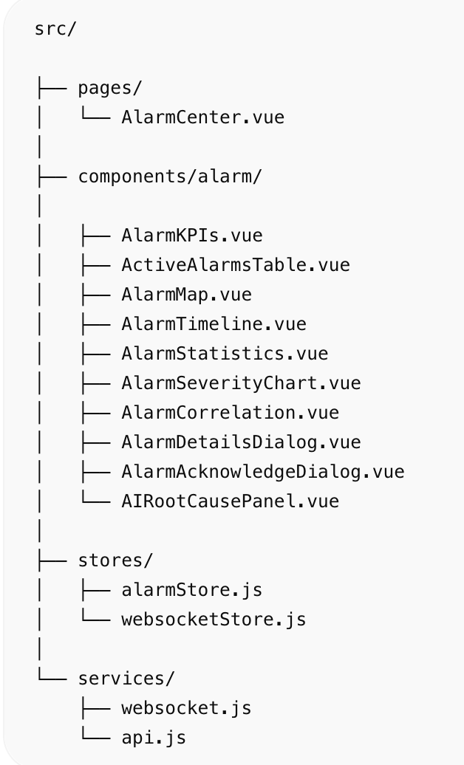 | src/  ├── pages/  │ └── AlarmCenter.vue  │  ├── components/alarm/  │  │ ├── AlarmKPIs.vue  │ ├── ActiveAlarmsTable.vue  │ ├── AlarmMap.vue  │ ├── AlarmTimeline.vue  │ ├── AlarmStatistics.vue  │ ├── AlarmSeverityChart.vue  │ ├── AlarmCorrelation.vue  │ ├── AlarmDetailsDialog.vue  │ ├── AlarmAcknowledgeDialog.vue  │ └── AIRootCausePanel.vue  │  ├── stores/  │ ├── alarmStore.js  │ └── websocketStore.js  │  └── services/  ├── websocket.js  └── api.js

AlarmCenter.vue
<template>  <q-page class="bg-dark text-white q-pa-md">  <AlarmKPIs />  <div class="row q-col-gutter-md q-mt-md">  <div class="col-8">  <ActiveAlarmsTable />  </div>  <div class="col-4">  <AlarmSeverityChart />  </div>  </div>  <div class="row q-col-gutter-md q-mt-md">  <div class="col-8">  <AlarmMap />  </div>  <div class="col-4">  <AIRootCausePanel />  </div>  </div>  <div class="row q-col-gutter-md q-mt-md">  <div class="col-6">  <AlarmTimeline />  </div>  <div class="col-6">  <AlarmCorrelation />  </div>  </div>  </q-page>  </template>  <script setup>  import AlarmKPIs from 'components/alarm/AlarmKPIs.vue'  import ActiveAlarmsTable from 'components/alarm/ActiveAlarmsTable.vue'  import AlarmSeverityChart from 'components/alarm/AlarmSeverityChart.vue'  import AlarmMap from 'components/alarm/AlarmMap.vue'  import AIRootCausePanel from 'components/alarm/AIRootCausePanel.vue'  import AlarmTimeline from 'components/alarm/AlarmTimeline.vue'  import AlarmCorrelation from 'components/alarm/AlarmCorrelation.vue'  </script> | 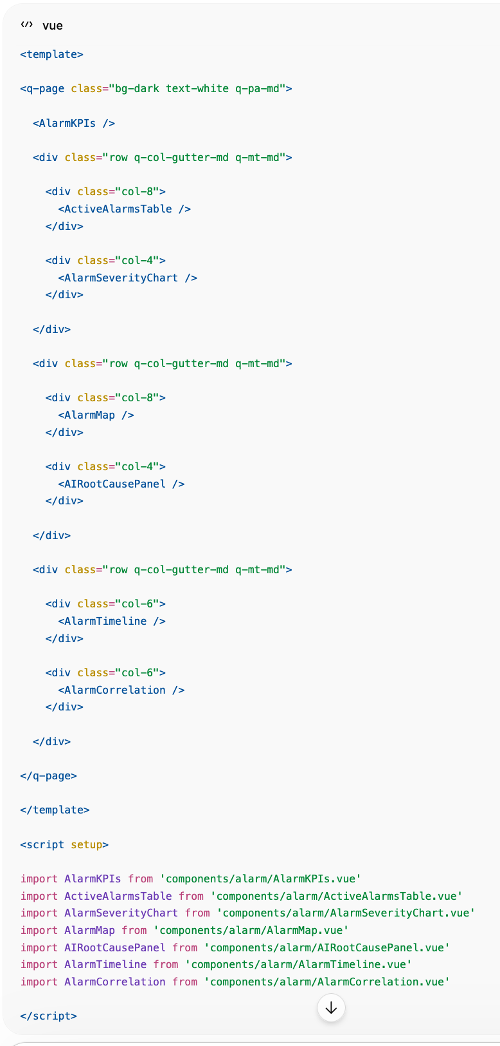

AlarmKPIs.vue
<template>  <div class="row q-col-gutter-md">  <div  class="col-3"  v-for="item in kpis"  :key="item.title"  >  <q-card dark bordered class="bg-grey-10">  <q-card-section>  <div class="text-grey">  {{ item.title }}  </div>  <div class="text-h4">  {{ item.value }}  </div>  </q-card-section>  </q-card>  </div>  </div>  </template>  <script setup>  const kpis = [  {  title:'Active Alarms',  value:127  },  {  title:'Critical',  value:12  },  {  title:'Acknowledged',  value:94  },  {  title:'Blackout Risk',  value:'12%'  }  ]  </script> | 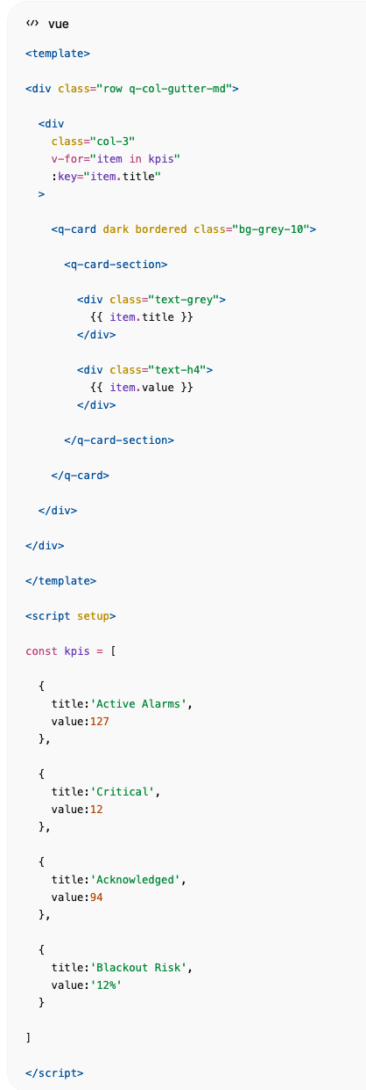

ActiveAlarmsTable.vue
<template>  <q-card dark bordered class="bg-grey-10">  <q-card-section>  <div class="text-h6">  Active Alarms  </div>  </q-card-section>  <q-table  dark  flat  bordered  :rows="rows"  :columns="columns"  row-key="id"  />  </q-card>  </template>  <script setup>  const columns = [  {  name:'time',  label:'Time',  field:'time'  },  {  name:'asset',  label:'Asset',  field:'asset'  },  {  name:'alarm',  label:'Alarm',  field:'alarm'  },  {  name:'severity',  label:'Severity',  field:'severity'  }  ]  const rows = [  {  id:1,  time:'14:22',  asset:'TR-0421',  alarm:'Oil Temperature High',  severity:'Critical'  },  {  id:2,  time:'14:25',  asset:'TS-042',  alarm:'Voltage Drop',  severity:'High'  }  ]  </script> | 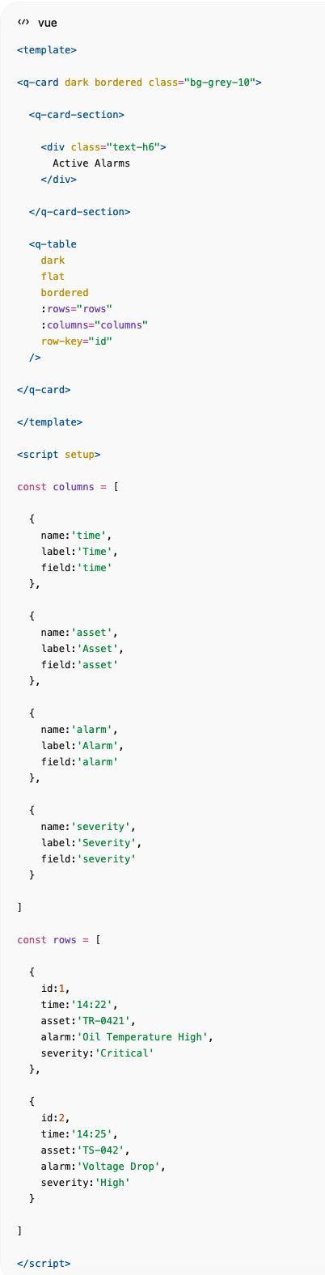

AIRootCausePanel.vue
<template>  <q-card dark bordered class="bg-grey-10">  <q-card-section>  <div class="text-h6">  AI Root Cause Analysis  </div>  </q-card-section>  <q-list separator>  <q-item>  <q-item-section>  Transformer TR-0421  <div class="text-grey">  Oil temperature rise likely caused  by cooling fan degradation.  </div>  </q-item-section>  </q-item>  <q-item>  <q-item-section>  Recommended Action  <div class="text-green">  Inspect cooling system  within 24 hours.  </div>  </q-item-section>  </q-item>  </q-list>  </q-card>  </template> | 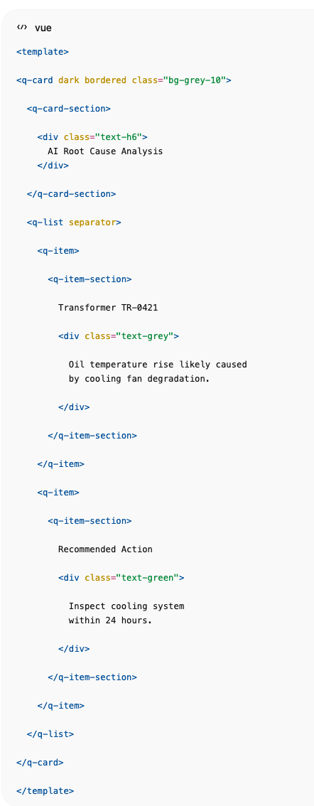

AlarmMap.vue
Za GIS prikaz svih alarma.
<template>  <q-card dark bordered>  <q-card-section>  Alarm Map  </q-card-section>  <div id="alarmMap"></div>  </q-card>  </template>  <style scoped>  #alarmMap{  height:500px;  }  </style> | 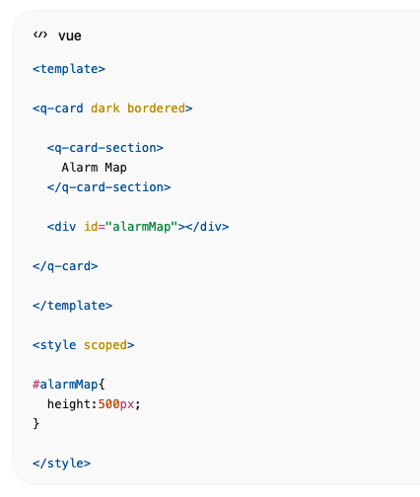

AlarmTimeline.vue
Prikaz eskalacije događaja.
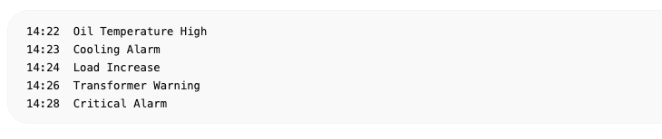

AlarmCorrelation.vue
AI grupira povezane alarme.
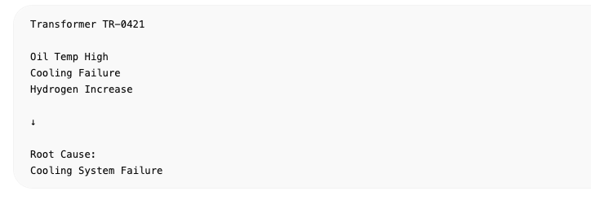

Pinia Store
import { defineStore } from 'pinia'  export const useAlarmStore = defineStore('alarm', {  state: () => ({  activeAlarms: [],  criticalAlarms: [],  acknowledged: [],  alarmStatistics: {},  alarmTimeline: [],  rootCauseAnalysis: []  })  }) | 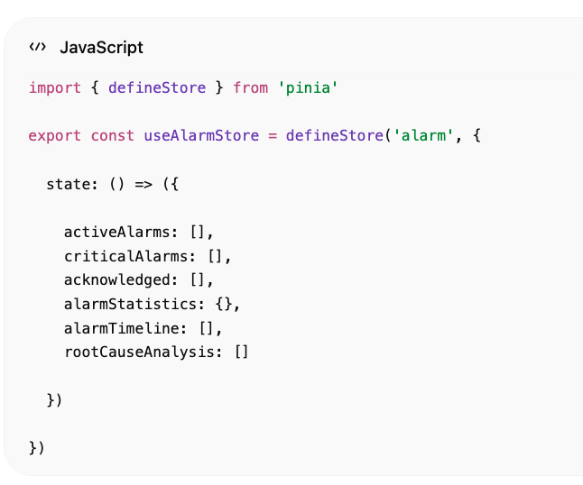

EMQX → Alarm Feed
MQTT topic:

Primjer poruke:
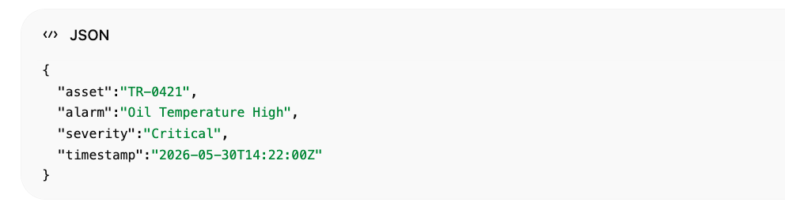

CrateDB tablice
alarms  CREATE TABLE alarms (  ts TIMESTAMP,  asset_id TEXT,  alarm_type TEXT,  severity TEXT,  acknowledged BOOLEAN  );  alarm_statistics  CREATE TABLE alarm_statistics (  day TIMESTAMP,  critical INTEGER,  high INTEGER,  medium INTEGER,  low INTEGER  );  alarm_root_cause  CREATE TABLE alarm_root_cause (  asset_id TEXT,  root_cause TEXT,  confidence DOUBLE  ); | 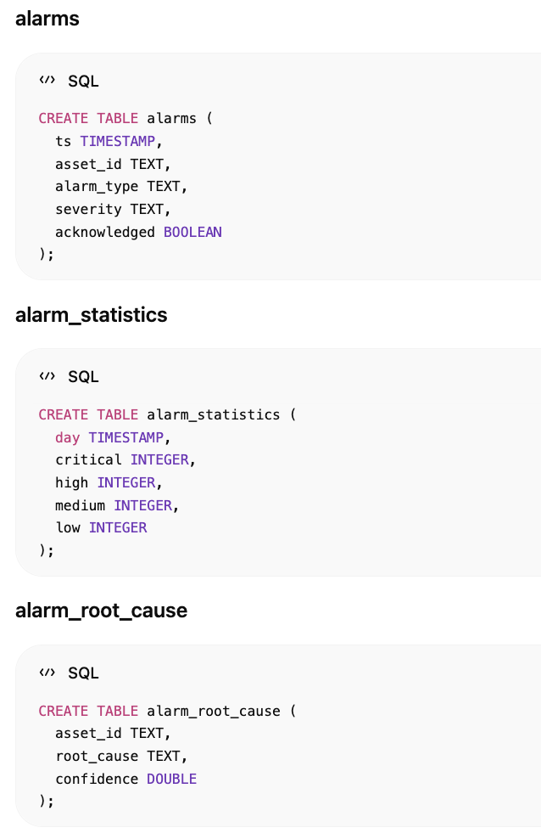

Enterprise funkcionalnosti
- Realtime MQTT alarms (EMQX)
- WebSocket push prema Vue aplikaciji
- GIS alarm mapa
- Alarm acknowledgement workflow
- Alarm escalation
- Alarm correlation engine
- AI root cause analysis
- Blackout risk alarms
- Transformer alarms
- Protection relay alarms
- Historical alarm analytics
- ECharts alarm trends
- Digital Twin integration (klik na alarm → otvara Transformer Twin)
Ovakav Alarm Center se vrlo dobro uklapa uz Dashboard, Grid Map, Analytics, Forecasting, Maintenance i Digital Twin module koje si već definirao za CrateDB Smart Grid platformu.

